|  |  |  |  |  |
| --- | --- | --- | --- | --- |
| logoSaoJOSE.wmf | **FUNDAÇÃO EDUCACIONAL CLAUDINO FRANCIO** **CENTRO DE EDUCAÇÃO BÁSICA SÃO JOSÉ** | | | |
| Disciplina: Inglês | Professora: Abielly / Luciana | | Data: ___/___/ 2020 |
| Aluno (a): ________________________________ - 3º Anos | | | Extra Exercises | |

1. Pinte cada **Number** da Color correta e, ao lado da color escreva a tradução:

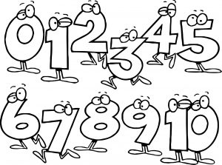

**Zero: Black __PRETO_One: Pink ______________Two: Green__________________ Three: Dark Blue________________Four: Purple_____________ Five: Yellow______________ Six: Orange_______________Seven: Brown_________________ Eight: Gray_____________ Nine: Red ______________ Ten: Light Blue_________________**

2. Desembaralhe as letras e forme os nomes das **FRUITS**:

a) NABANA: ______________________

b) DOCAVOA: _____________________

c) BYRRELABKC: ___________________

d) REPA: _________________________

3. Escreva por extenso as **HOURS** abaixo:

**3:00**

__________________________________________

**12:00**

__________________________________________

**8:00**

__________________________________________

**6:00**

__________________________________________

**9:00**

__________________________________________